INFS3203
Systems Deployment & Implementation
Winter 2026 · University of Doha for Science & Technology
Team Project
Final Submission Template
Presentation: Week 14

Submit a single .zip file containing: (1) all source code (including .git folder), but without dependency folders (no node_modules/, no venv/, no __pycache__/), (2) your presentation file (.pptx or .pdf), and (3) this completed submission template. Name the zip: INFS3203_Project_TeamName.zip

Part 1 — Team Information
 | Name | Student ID | GitHub Account
Member 1 | Tatheer Batool | 60303339 | TatheerB
Member 2 | Akmal Saleem | 60098173 | Akmal-Saleem-60098173

App Name | AI Study Assistant
GitHub Repository URL | https://github.com/TatheerB/ai-study-assistant
Live App URL | https://ai-study-assistant-group2.onrender.com
Container Image URL | https://hub.docker.com/r/tatheerbatool/ai-study-assistant
Cloud Provider Used | Render.com
Database Used | MongoDB Atlas
Date Submitted | April 5, 2026

Team Role Summary
Briefly describe each member's primary ownership area and main contributions to the project.
Member | Role Title | Primary Contributions
Tatheer | DevOps & Full-Stack Developer (Flashcards + Quiz) | Built complete flashcard and quiz features with Gemini API integration. Created interactive flashcards (15 cards with flip animation) and quiz (20 multiple-choice questions). Implemented CI/CD pipeline with GitHub Actions, Docker containerization, and Render deployment.
Member 2 | Full-Stack Developer (Summary + Database Integration) | Built the summary generation feature with Gemini API integration and connected it to the frontend UI. Implemented MongoDB integration to save, retrieve, and manage study history. Designed and improved the history page UI with preview and “view more” functionality for better usability. Handled debugging of API and database issues, ensuring smooth integration between frontend and backend components.

Part 2 — GitHub Activity Summary
Summarize your team's GitHub activity across the three project weeks. This section helps the instructor understand the distribution of work and cross-references the activity visible in your repository.

2.1 Contribution Overview
Member | Commits | PRs Opened | PRs Reviewed | Issues Closed
Member 1 – Tatheer Batool | 36 | 9 | 5 | 5
Member 2 – Akmal Saleem | 25 | 9 | 6 | 12

These numbers are subject to be verified against the GitHub repository. Ensure your repo is public* and all activity is visible before submitting.
* Contact your instructor if you have a valid reason for using a private repo.

2.2 Weekly Progress Log
For each week, briefly describe what the team accomplished and any significant decisions or challenges encountered.
Week | Summary of Progress, Decisions & Challenges
Week 11 | Tatheer:  - Created GitHub repository and project board with 5 issues  - Built Flask app skeleton with health check endpoint  - Designed HTML/CSS templates for flashcards and quiz pages  - Created JavaScript structure for interactive components  - Set up Dockerfile and tested locally  - Established feature branch workflow  Akmal:  - Set up initial backend structure using Flask  - Implemented basic routes and started working on summary feature  - Explored MongoDB Atlas setup and database connection  - Faced some initial issues with environment setup and API understanding  Team Summary:  - Set up project infrastructure and proposal  - Created develop branch and feature branch strategy  - Initial issues created for all features  - App skeleton running locally with health check  - Dockerfile created and tested  Challenges:  - Learning proper Git workflow with branches and PRs  - Ensuring .env file with API keys was properly ignored
Week 12 | Tatheer:  - Built interactive flashcard UI with flip animation and navigation  - Built quiz UI with 20 multiple-choice questions and scoring  - Integrated Gemini API for flashcards (15 cards per topic)  - Integrated Gemini API for quiz (20 unique questions)  - Added duplicate prevention for flashcards  - Added HTML escaping for special characters in quiz  - Created GitHub Actions CI pipeline  Akmal:  - Integrated Gemini API for summary generation  - Fixed issues with incorrect API endpoint by switching to the correct one provided by the instructor  - Connected backend with frontend for summary feature  - Started implementing save functionality using MongoDB  - Faced errors with API responses and debugging integration issues  Team Summary:  - All AI-powered features working end-to-end  - MongoDB Atlas connected for data persistence  - CI pipeline running green on every push  - 12+ unit tests written and passing  Challenges:  - Gemini API was initially disabled (professor resolved)  - Fixing duplicate flashcard issues (added uniqueness check)  - HTML special characters breaking quiz display (added escaping)
Week 13 | Tatheer:  - Fixed duplicate flashcards issue with deduplication logic  - Fixed quiz options validation (ensured 4 options per question)  - Completed CI/CD pipeline with Docker Hub push  - Deployed application to Render.com  - Added actual environment variables (GEMINI_API_KEY, MONGODB_URI) to Render  - Took all required screenshots  - Prepared submission documentation  Akmal:  - Completed MongoDB integration for saving and retrieving study sets  - Fixed database connection issues (connection string and network access problems)  - Implemented study history feature with clean UI (short preview + “view more”)  - Tested full system including summary, save, and history features  - Helped identify bugs during testing (quiz issues and duplicate flashcards) and supported overall system stability  - Recorded video for the demo  - Did my part in the submission documentation.  Team Summary:  - Full CI/CD pipeline operational  - Live app at https://ai-study-assistant-group2.onrender.com  - All AI features working in production  - Presentation slides prepared  - All issues closed  Challenges:  - CI pipeline initially only ran on [main], so PRs to develop weren't triggering (fixed by changing workflow to [develop, main])  - Smoke test failing in CI (resolved by adding environment variables to Render)  - Docker image name mismatch between build and test steps  - Render environment variables missing initially (added after deployment)

Part 3 — Evidence Screenshots
Paste each screenshot directly into this document (Insert → Pictures) or attach as labelled separate files. Every screenshot showing the running application must include the team name or a member's student ID visible somewhere in the interface.

📸 Screenshot 1 — App Running Locally
Show the application running in a browser at localhost. At least one AI-powered feature should be active and visible.
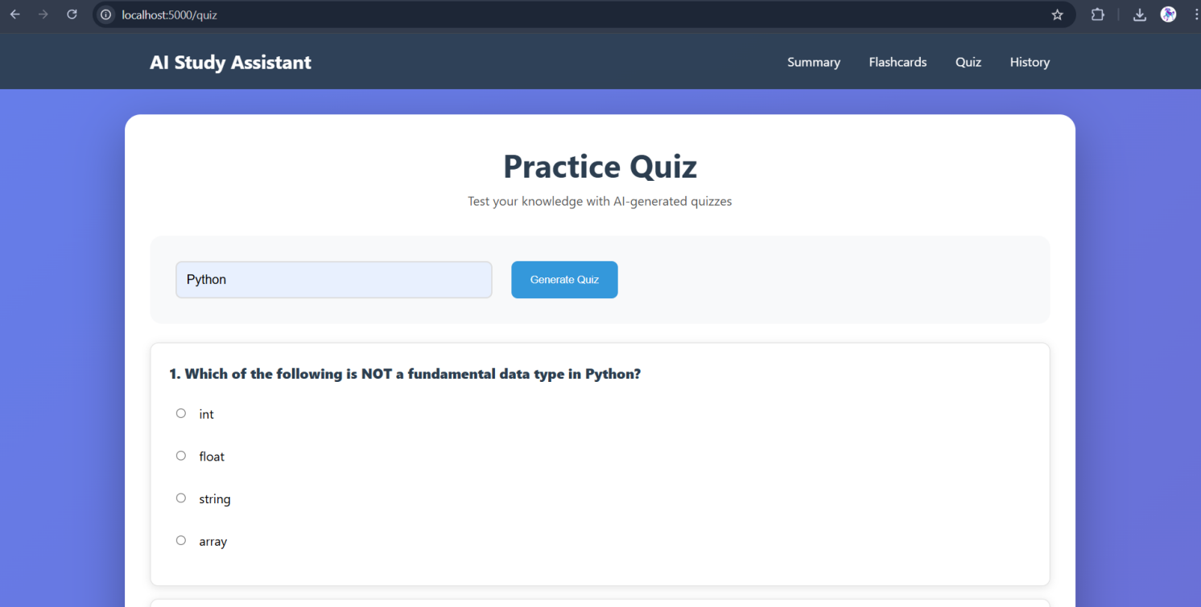

📸 Screenshot 2 — Database Content
Show the database with real data populated from app usage (e.g. a query result, a collection view, or a dashboard screenshot from your cloud DB provider).
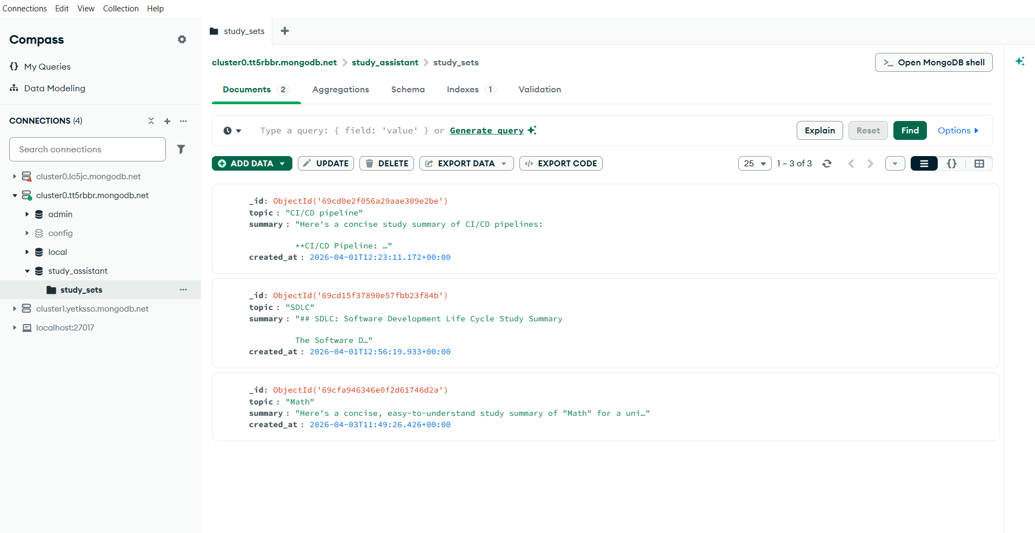

📸 Screenshot 3 — Application Running in a Container
Show the app running from inside a Docker container (browser at localhost, served from the container). Include the docker run command used.
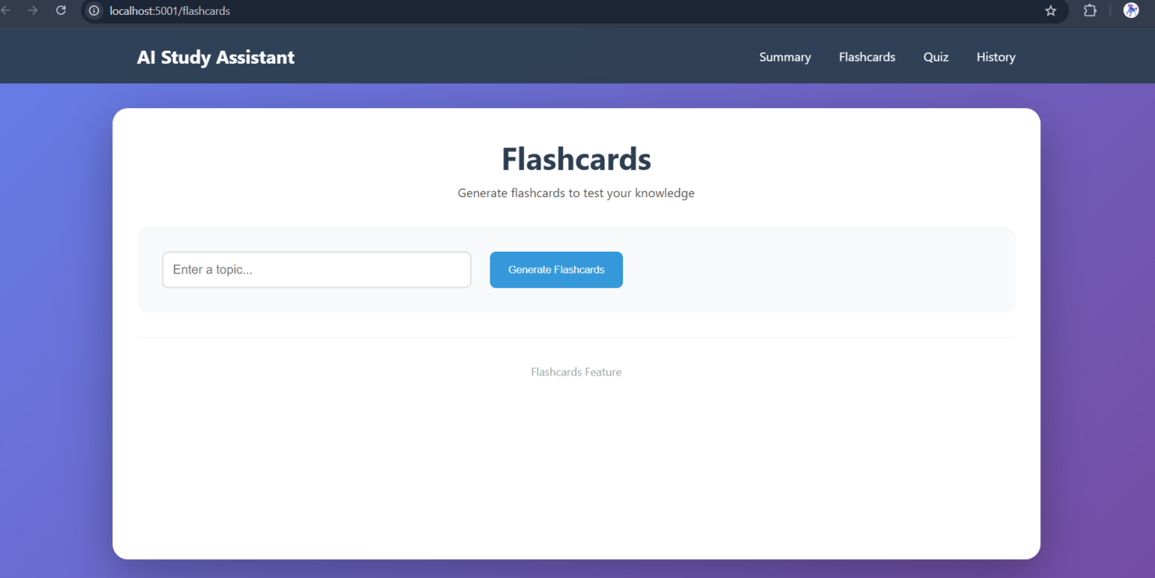

📸 Screenshot 4 — CI Pipeline Green
GitHub Actions tab showing the CI job passing (all steps green) on a push or pull request to main.
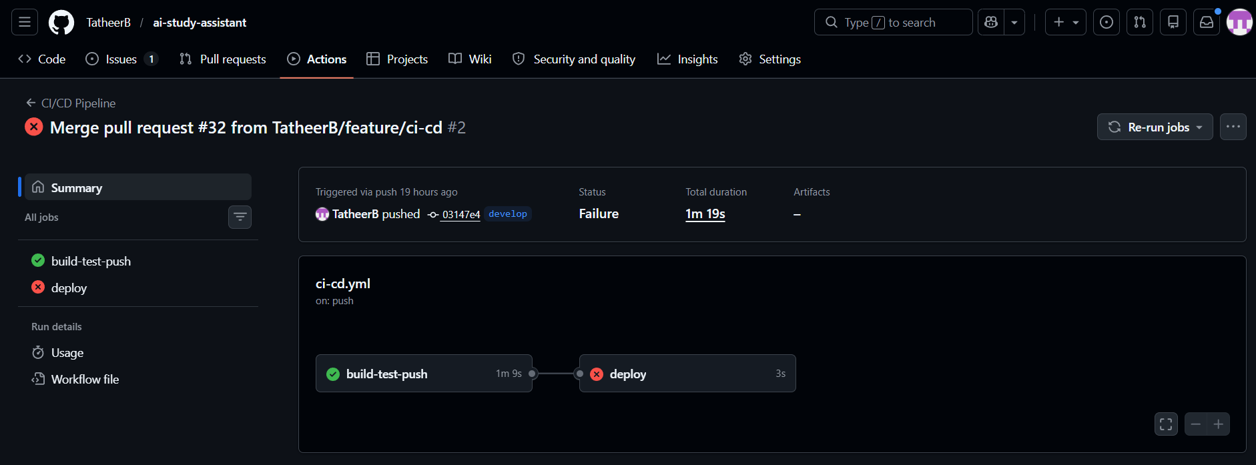

📸 Screenshot 5 — CD Pipeline Green & Deployment Triggered
GitHub Actions tab showing the CD job passing and the deploy hook triggered. Both CI and CD jobs should be green on the same run.
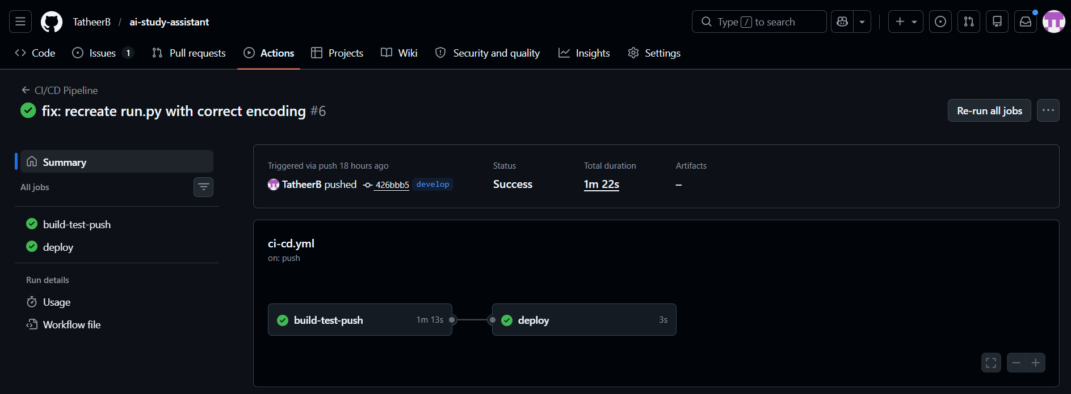

📸 Screenshot 6 — Live App on Cloud
Browser showing the application at your live public URL (address bar clearly visible). An AI feature should be active to confirm the full stack is working end-to-end.
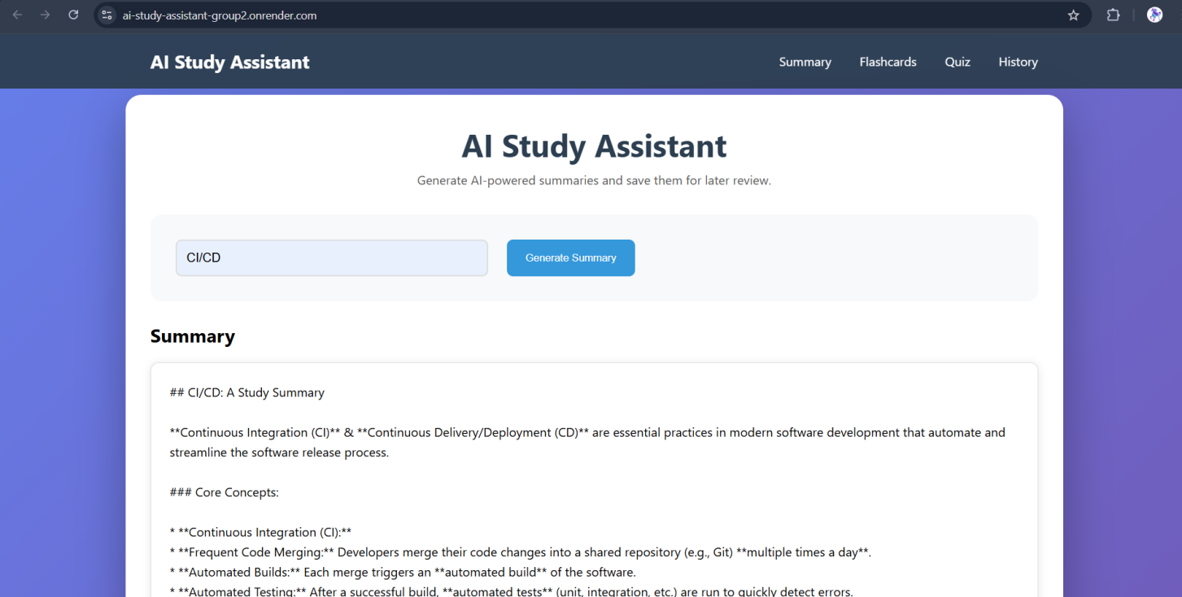

📸 Screenshot 7 — GitHub Project Board
Show your project board at or near the end of Week 13, with issues in the Done column and the overall progress visible.
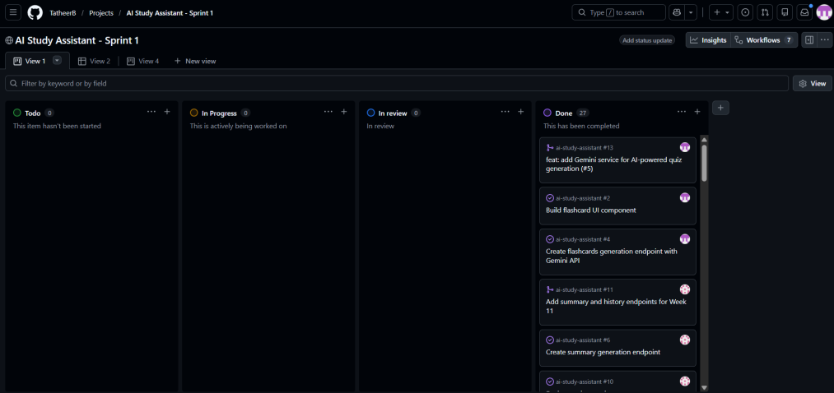
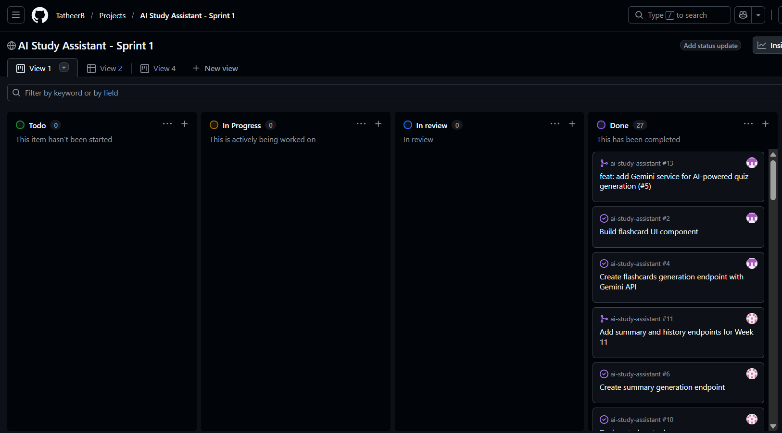
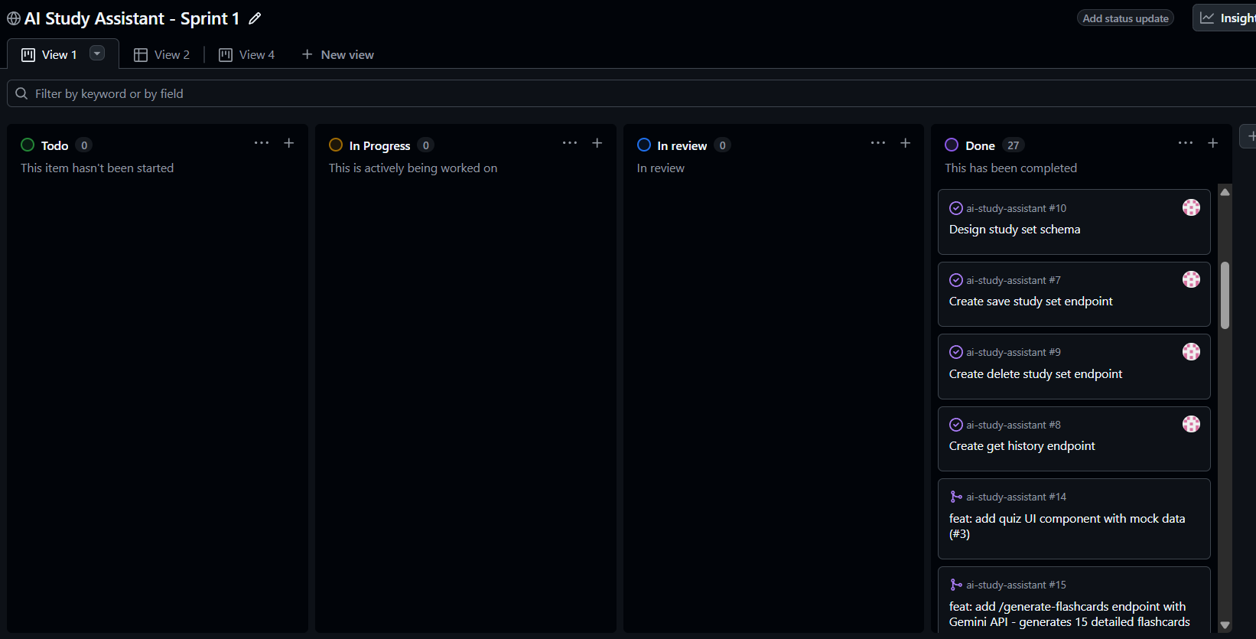
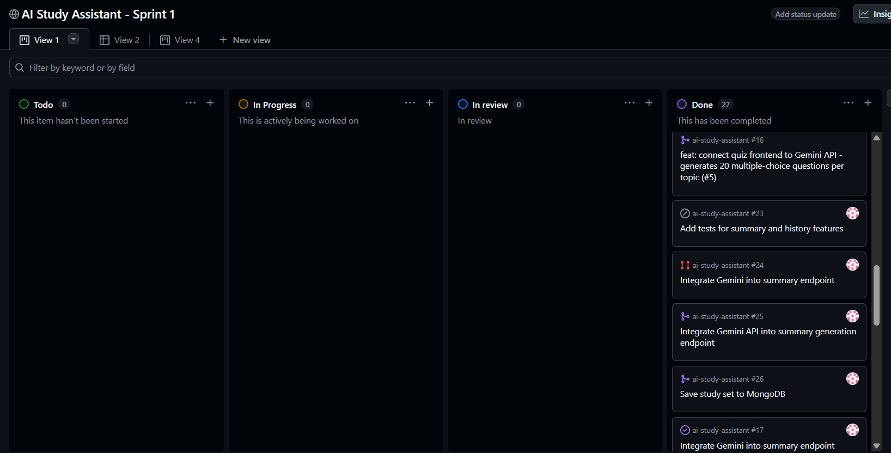

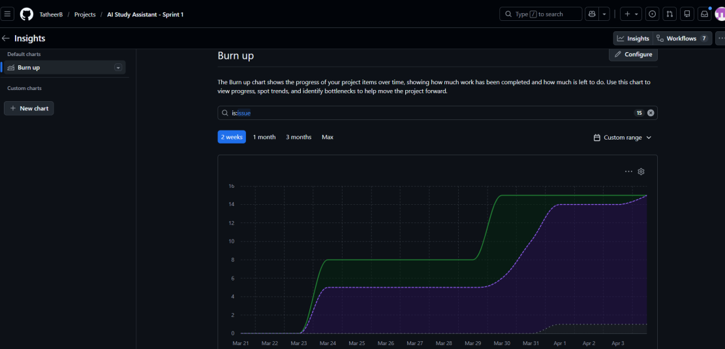

Part 4 — Individual Reflections
Each team member answers the questions in their own section below. Answers should be written individually and reflect genuine personal perspective. Aim for 3–5 sentences per question. Technical accuracy and honesty matter more than length.

Member 1 Reflections - Tatheer

Q1. What was your primary contribution to the project? Describe the most technically challenging part of what you built and how you solved it.
Answer (aim for 3–5 sentences):
My primary contributions were building the flashcard and quiz features from scratch, including the frontend UI, Gemini API integration, and the complete CI/CD pipeline. The most technically challenging part was fixing duplicate flashcards and flashcards overflowing because answers were too long, which I solved by adding deduplication logic and shortening the answer prompt to 1 word or 1 sentence. For the quiz, I struggled with options containing <> symbols not displaying and missing options entirely, so I added HTML escaping and validation logic to ensure every question has exactly 4 options. For CI/CD, I fixed the smoke test failing because the container wouldn't stay alive by adding environment variables and updated the workflow trigger from [main] to [develop, main] so PRs would be tested before merging.

Q2. Describe a specific moment where you demonstrated initiative — either by anticipating a problem, proposing an improvement, or unblocking a teammate. What was the impact?
Answer (aim for 3–5 sentences):
When testing the quiz feature, my teammate pointed out that for some questions, options weren't showing up. I noticed that questions with options containing < and > symbols were not displaying properly in the browser because the browser was interpreting them as HTML tags. I took the initiative to research the issue and implemented HTML escaping in the function, converting special characters to their safe HTML entities using a custom function. This fixed the display issue and ensured all options showed correctly regardless of their content.

Q3. How did the CI/CD pipeline change the way your team worked? Give a specific example of the pipeline catching a problem or preventing a bad deployment.
Answer (aim for 3–5 sentences):
The CI/CD pipeline forced us to adopt proper branch discipline where all features went through develop branch before reaching main, and every PR required a passing CI check before merging. One specific example was when the smoke test failed because the container wouldn't stay alive. The pipeline logs showed the Flask app was crashing due to missing environment variables, so I added GEMINI_API_KEY and MONGODB_URI to the GitHub Actions workflow secrets. This fixed the pipeline and ensured all future PRs would be properly tested before deployment.

Member 2 Reflections - Akmal

Q1. What was your primary contribution to the project? Describe the most technically challenging part of what you built and how you solved it.
Answer (aim for 3–5 sentences):
My main contribution was building the summary feature, connecting it to the Gemini API, and integrating it with MongoDB so users can save and view their study history. The most challenging part was getting the API and database to work together correctly, especially when I faced errors with the API endpoint and MongoDB connection timeouts. I solved this by switching to the correct Gemini endpoint provided by the instructor and fixing the connection string and network access settings in MongoDB Atlas. Another challenge was making the history page clean and readable, so I improved the UI by showing only a short preview with a “view more” option.

Q2. Describe a specific moment where you demonstrated initiative — either by anticipating a problem, proposing an improvement, or unblocking a teammate. What was the impact?
Answer (aim for 3–5 sentences):
While testing the system, I noticed a bug in my teammate’s implementation where the quiz was generating the same 20 questions without any options, and the flashcards were repeating questions starting from question 7. Instead of ignoring it, I reported the issue clearly with examples and explained what was happening. This helped identify the problem faster, and my teammate was able to fix it by improving the generation logic. Finding this bug early prevented incorrect data from being shown to users and improved the overall quality of the application.

Q3. Looking at your GitHub activity (commits, PRs, reviews), does it accurately reflect your real contribution? Is there anything the numbers do not capture?
Answer (aim for 3–5 sentences):
My GitHub activity shows most of my work, including commits, pull requests, and reviews, but it does not fully reflect the effort I spent debugging and testing. A lot of time went into fixing API errors, MongoDB connection issues, and making sure everything worked correctly before committing. I also spent time coordinating with my teammate and reviewing their work, which is not always visible in the commit history. So while the activity gives a general idea, it does not show the full amount of work behind the scenes.

Part 5 — Team Reflection
Answer the following questions together as a team. These should reflect a shared perspective, not just one member's view.

Q1. How did your team define and distribute goals and tasks at the start of the project? Did the plan change over the three weeks, and if so, why?
Answer (aim for 3–5 sentences):
At the beginning, we divided the project based on features, where one of us focused more on the frontend and CI/CD, and the other focused on backend features like summary generation and database integration. This helped us work faster because each person handled what they were more comfortable with. As the project progressed, the plan slightly changed because we had to fix bugs and adjust based on testing results. We also helped each other when something was not working, especially during integration. This flexible approach made it easier to complete the project on time.

Q2. What was the most significant technical or teamwork challenge your team faced? How did you address it as a group?
Answer (aim for 3–5 sentences):
One of the biggest challenges we faced was managing our time and availability, since we were not always free at the same time. There were situations where one team member was available while the other was busy, which made coordination and communication slower. This also affected pull request reviews, as delays in feedback sometimes slowed down our progress. To handle this, we decided to work on our tasks independently within a set time and keep each other updated regularly. This approach helped us continue working efficiently and reduced delays even when we could not work at the same time, which is a common issue in team collaboration.

Q3. If you had one more week, what would you add or improve — technically and in terms of how the team worked together?
Answer (aim for 3–5 sentences):
If we had one more week, we would improve the UI design further to make it more polished and user-friendly. We would also add more advanced features, such as better filtering for study history or improving AI-generated content quality. From a teamwork perspective, we would plan tasks earlier and organize testing more systematically. This would help reduce last-minute fixes and make the workflow smoother. Overall, we would focus on both improving the user experience and making our collaboration even more efficient.

Part 6 — Submission Checklist
Complete this checklist before submitting. Every item should be checked. If something is missing, do not submit until it is addressed or clearly explained.

✓ | Item | Status / Notes
✓ | Source code included in .zip (without dependency folders: no node_modules/, venv/, __pycache__/) | DONE
✓ | Dockerfile present in the root of the project | DONE
✓ | GitHub Actions workflow file (.github/workflows/) included in the code | DONE
✓ | README.md present with app description, setup instructions, and live URL | DONE
✓ | Unit tests included in the repository and passing | DONE
✓ | No sensitive credentials committed (no .env files, no API keys in source code) | DONE
✓ | GitHub repository is public and accessible at the URL provided above | DONE
✓ | GitHub Project Board shows issues across all three weeks with activity from all members | DONE
✓ | All features were merged via pull requests (no significant direct commits to main) | DONE
✓ | All team members have visible commits, PRs, and issue activity in the repository | DONE
✓ | CI pipeline runs automatically on push and pull request — all steps green | DONE
✓ | CD pipeline triggers automatically on push to main and deploys to the cloud provider | DONE
✓ | Live app is accessible at the public URL provided above | DONE
✓ | All AI-powered features are working on the live deployment | DONE
✓ | Presentation file included in the .zip (.pptx or .pdf) | DONE
✓ | This submission template is fully completed (all sections filled in, all screenshots inserted) | DONE
✓ | All team members have reviewed and agreed on the contents of this document before submission | DONE

By submitting this document, each team member confirms that the work is their own, that contributions are accurately represented, and that the team has adhered to the academic integrity policies of the University of Doha for Science & Technology.

Team Sign-off
Member 1 | Member 2
Name: Tatheer Batool_______________  Date: _4/7/2026___________________ | Name: _Akmal Saleem__________________  Date: _4/7/2026___________________

